**DAV HZL SR. SEC. SCHOOL, DARIBA**

**TENTATIVE CO-CURRICULAR ACTIVITIES 2024-25**

|  |  |  |
| --- | --- | --- |
| **Date** | **Class** | **Activity (Events)** |
| 06/04/2024 | III TO V | Cinematic Odyssey: Arya Samaj Chronicles |
| VI TO VIII | Narrative Alchemy: Crafting English Tales |
| IX TO XII | Lens Enchantment: Interclass Cinematic Journey |
| 20/04/2024 | III TO V | Soliloquy Symphony: Mastering English Monologues |
| VI TO VIII | Dramatic Flourish: Theatrical Skits in English |
| IX TO XII | Electoral Insights: Interclass PowerPoint Showdown |
| 04/05/2024 | III TO V | Artistry Unleashed: Collage Creation Extravaganza |
| VI TO VIII | Sculpting Stories: From Clay to Chronicle |
| IX TO XI | Pixel Perfection: Design Delights with Photoshop |
| 05/07/2024 | III TO VIII | Green Horizon: Plantation Expedition |
| 06/07/2024 | III TO V | Calligraphy |
| VI TO X | Echoes of Ecology: English Environmental Orations |
| 11/07/2024 | III TO XII | Leadership Unveiled: Investiture Spectacular |
| 20/07/2024 | III TO V | Lexical Showdown: Spellbinding Spell Bee |
| VI TO VII | Verbal Voyage: Vocabulary Ventures |
| IX TO XI | Enlightening Discourse: TED Talk Showdown |
| 03/08/2024 | III TO V | Culinary Chronicles: Fireside Cooking & Artistry |
| VI TO IX | Taste Temptations: Culinary Competition |
| 17/08/2024 | III TO VIII | Cultural Kaleidoscope: Rangoli, Rakhi& Arya Samaj Quizzes |
| 31/08/2024 | III TO V | Social Science Showdown: Quiz Quest |
| VII TO X | Parliamentary Prowess: Youth Debate Showdown |
| 06/09/2024 | III TO V | Hindi Heritage: Crafting Original Stories & Poems |
| VI TO VII | Hindi Heritage: Crafting Original Poems |
| VIII TO X | Declamatory Divinity: Hindi Oratory Odyssey |
| 05/10/2024 | III TO V | Blogosphere Brilliance: Crafting Digital Chronicles |
| VI TO VII | Wall Wonders: Mural Masterpieces |
| VIII | Wonders on earthen plates |
| 19/10/2024 | III TO V | Moral Mosaic: Hindi Skits on Values |
| VI TO IX | Theatrical Tribute: Great Personality Dramatizations |
| 08/11/2024 | III TO V | Melodic Medley: Songster Showdown |
| VI TO IX | Devotional Delights: Bhajan Bliss |
| 23/11/2024` | III TO V | Innovation Illuminated: Inventors' Showcase |
| VI TO VII | Journey of a Dreamer;Biography |
| VIII TO IX Sci. | Scientific Sorcery: Enchanting Science Magic |
| 07/12/2024 | III TO V | Literary Legacy: Bookmark Bonanza |
| VI TO VIII | Informative Imprints: Brochure Brilliance |
| 21/12/2024 | III TO IX | Math Marvels: Exploring Fun & Practical Mathematics |
| 18/01/2025 | III TO VII | Patriotic Penmanship: Slogan Sketching & Doodling |
| 31/01/2025 | III TO V | Resourceful Innovation: Waste Material Wonders & Presentations |

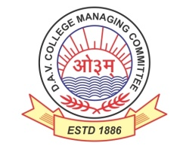

DAV HZL Sr. Sec. School dariba

rajsamand (raj.)

DAV HZL Sr. Sec. School dariba, rajsamand(raj.)

Split-up Syllabus

Class- III

Split-up Syllabus & Activities

for the session

2024-25

Class-VII

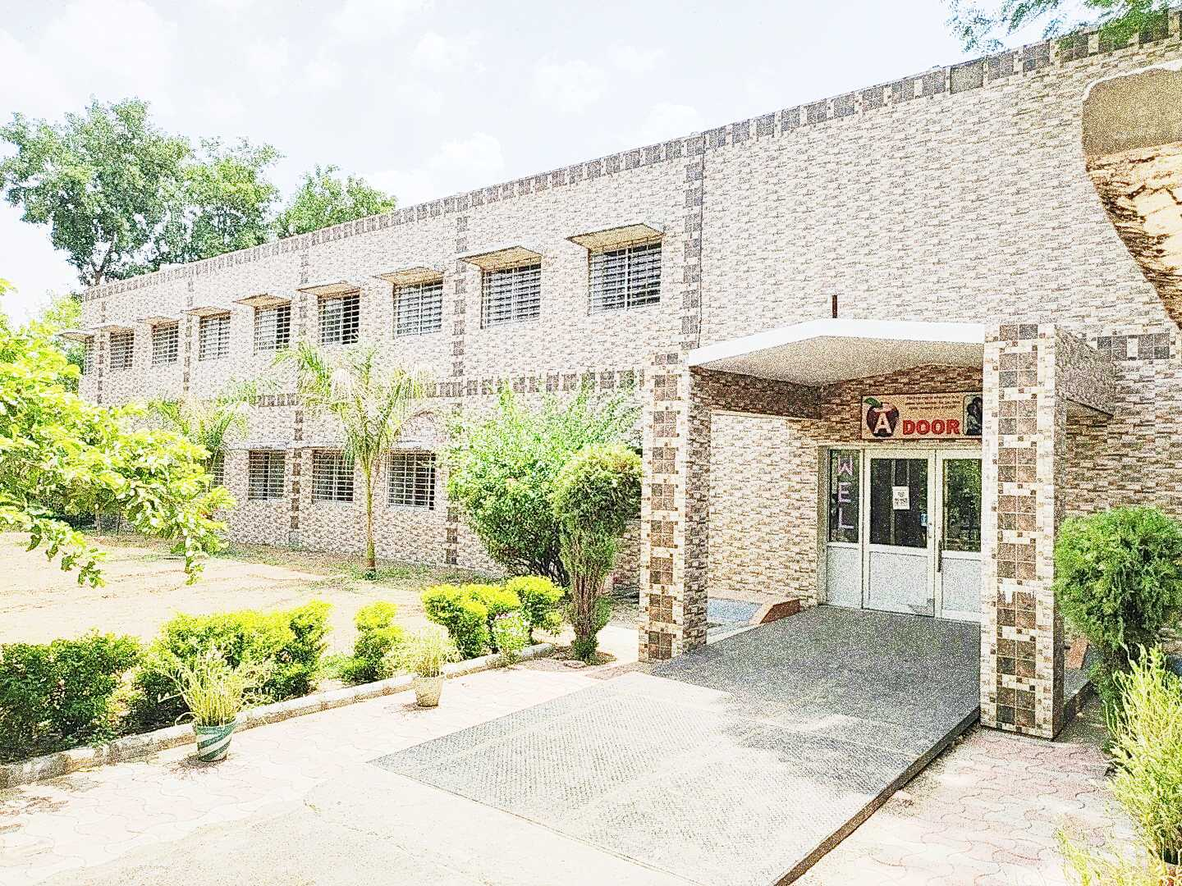

Address : Rajpura-Dariba, Distt. – Rajsamand (Raj.) 313211

Contact : (02952)265130 Email : davhzl_dariba@yahoo.com Website : www.davhzldariba.in

|  |  |  |
| --- | --- | --- |
| **Subject** | **PT- I** | **PT- II** |
| English | Lit. book L-1,2  Practice book-L-1 | Lit. book-L-3,4  Practice book-L-2 |
| Hindi | पाठ-1,2 (ज्ञानसागर,अभ्यास सागर) | पाठ-3,4 (ज्ञान सागर,अभ्यास सागर) |
| Maths | Chapter-1,2 | Chapter-3,4 |
| Science | L-1,2 | L-3,4 |
| S.St. | L-1,9 | L-10,11,18 |
| laLÑr | L-1,2,उपसर्ग,अव्यय | L-3,4 सर्वनाम शब्द रूप, दीर्घ व गुण संधि |
| Computer Sc. | L-1 | L-2 |
| Moral Edu. | L-1,2 | L-3,4 |
| G. K. | Unit -1 | Unit-2 |

|  |  |
| --- | --- |
| **Subject** | **Mid Term** |
| English | Lit. book-L-1,2,3,4,5,6 Practice-L-1,2,3,4,5  Reader book-Unit-1,2,3 |
| Hindi | पाठ-1से10(ज्ञान सागर,अभ्यास सागर)  अपठित गद्यांश,अपठित काव्यांश,कॉपी में करवाया गया कार्य। |
| Maths | Chapter-1 to 6,13 |
| Science | L-1 to 8 |
| S. St. | L-1,2,3,4,9,10,11,12,13,14,18,19,20 |
| laLÑr | पाठ 1 से 5 व्याकरण-वर्ण संयोजन व विच्छेद , सर्वनाम शब्दरूप  धातुरूप संधि , अव्यय- उपसर्ग, प्रत्यय , संख्या 1 से 50 , कारका: , vifBr x|ka”k पत्र लेखन , चित्र वर्णन, संवाद लेखन , कथा लेखन |
| Computer Sc. | L-1to 4 |
| Moral Edu. | L-1 to7,आर्य नियम (1-5) |
| G. K. | Unit-1,2,3 |
| Drawing | Pg No.-5 to 23 |

|  |  |
| --- | --- |
| **Subject** | **PT- III** |
| English | Lit.book-L-7,8 , Practice Book L-6 |
| Hindi | पाठ -11,12 (ज्ञान सागर,अभ्यास सागर) |
| Maths | Chapter-7,8 |
| Science | L9,L10 |
| S.St. | L-5,19,21 |
| laLÑr | L-7,8, संवाद व पत्र लेखन |
| Computer Sc. | L-5,6 |
| Moral Edu. | L-8,9 |
| G. K. | Unit-4 |

|  |  |
| --- | --- |
| **Subject** | **Final Term** |
| English | Lit book-7,8,9,10,11 Practice book-L-6,7,8,9,10,11  Reader book-Unit-4,5,6 |
| Hindi | पाठ - 11से 20 (ज्ञान सागर,अभ्यास सागर)  अपठित गद्यांश,अपठित पद्यांश,कॉपी में करवाया गया कार्य |
| Maths | Chapter-7 to 12,14,4,6 |
| Science | L9 to L17 |
| S.St. | L-5,6,7,8,15,16,17,19,20,21,22,23 |
| laLÑr | पाठ 6 से 10 व्याकरण-वर्ण संयोजन व विच्छेद , सर्वनाम शब्दरूप  धातुरूप संधि , अव्यय- उपसर्ग, प्रत्यय , संख्या 51 से 100 , कारका: , vifBr x|ka”k पत्र लेखन , चित्र वर्णन, संवाद लेखन , कथा लेखन |
| Computer Sc. | L - 5 to 8 |
| Moral Edu. | L-8 to 13 (आर्य नियम 6-10) |
| G. K. | Unit- 4 to 6 |
| Drawing | Pg No.-24 to 47 |

|  |  |
| --- | --- |
| **Exam** | **TENTATIVE DATES OF EXAM** |
| **PT – I** | First Week of May 2024 |
| **PT- II** | First Week of August 2024 |
| **MID – TERM** | Third Week of September 2024 |
| **PT – III** | Last week of November 2024 |
| **FINAL TERM** | Last Week of Feb.2025 |